Project Requirements Specification
Assets Management System
Author: Selena Shen
Last Updated: 10/28/13

Executive Summary
This document specifies the requirements of Augmentum internal Assets Management System. This is an initial system requirement collect from Augmentum function support team. It is used for developer team to generate functional specification, and for QA team to write test plan.
Document History
Date | Author | Summary of Change | Note
2011/12/26 | Billy He | Initial version.
2011/12/30 | Berton Wu | Add more attributions of assets
2012/01/04 | Billy He | Update according to comments from IT and Finance
2012/01/05 | Alec Chen | Update functions of different roles
2013/07/05 | Selena Shen | Update functions and add new functions
Table of Contents

Table of Contents 3
Table of Contents 3
Table of Contents 3
Table of Contents 3
Table of Contents 3
Table of Contents 3
Table of Contents 3
Table of Contents 3
1 Project Deliverables 4
2 Schedule 5
3 Project Requirements 6
User Type 6
Assets Assignment Workflow 7
Assets Management 8
Assets Creation 10
Assets Info update 12
Confirm Process 12
Process of project assets 13
Authentication/Authorization 13
Dash Board 13
Search 17
Customized Column 17
Other functions 17
4 Prerequisite Tools (minor version is flexible) 18
5 Required Design Choices (minor version is flexible) 19
6 New Feature (Need Confirm) 20

Project Deliverables
The project is considered complete when the following deliverables have been fulfilled.

- Project Plan
- Functional Specification
  - Follows the FunctionalSpecTemplate.doc
  - Synchronized with code
- Code Complete
  - Source Code
  - Release Build
  - Release Notes
- Unit Test
  - Unit Test Code
  - Automated Test Scripts
  - Execution Report
- Functional Test
  - Test case design
  - Test report
- Feature Complete Checklist
- Bug List

Note: All code must conform to the Java Coding Convention.

Schedule
The project will be developed by using Scrum model. Each scrum iteration will be 2 weeks. The first day of each iteration is the planning day, and the last day will be demo and retrospective day. There will be daily scrum meeting every morning. All the tasks, estimations will be defined on the planning day, and inputted into Trac system. Every team member must follow the estimation from planning meeting, and update progress every day before leaving company.

Project Requirements

User Type
There are six roles of users in the system:
Employee
- The user of the assets
- View the assets that he/she owns
- Take over the assets which belongs to his/her project, and the customer of this project should be shared
- Return assets back to customer, if the customer is a shared customer

Special Role
- Manager can assign a special role to employee, let user do the same work as a manager in a customer project, no matter customer is a shared customer or not.
- View transfer log of one asset

Manager
- Confirmed the assets are received
- Return the assets to IT/Customer
- Assign/Reassign employee the assets in his/her project
- View the assets that belongs to his/her project
- Maintain all info of assets shipped by customer in his/her project
- Define his/hers own asset property for one customer and one type

IT
- Confirm newly coming assets
- Assign assets to managers and ask for confirmation
- Confirm the assets are returned
- Maintain all assets info
- Batch generate bar-code for assets or batch remove bar-code for assets
- Upload the inventory file (.csv format) for audit
- Import assets from file (excel)
- Process assets audit
- View assets transfer log
- Export all asssets
- Batch update the fixed assets value
System Admin
- Assign IT role to a user
- View all assets info
- View operation log
- View assets transfer log
- Maintain all locations info
- Maintain shared customer list
- Maintain scheduler tasks

Assets Assignment Workflow

IT Create
assets
Manager
Create
assets
Import
assets
All Assets
List
IT
assign
assets
Manager
assign
assets to
Leaders
Leader
Assign
assets to
employees
Employee
Assets list
Assign
Assign
Assign
...

Assets Management
Assets Management has seven sub menus, there are
All Assets list
All Fixed Assets list – only IT can view

An asset can be any kind of company property. There is hardware assets like computer, monitor; there is software assets like software license; there is also non-IT assets like air-condition, refrigerator. An asset should contain following info:
- ID: number shown in the list (not uuid), is a readable number
- Name: The brief name of this asset. e.g. ViewSonic LCD.
- Type: The type of this asset. e.g. Hardware, Software.
- Bar-code: The Bar code generated system
- Check-in date: The date time when the assets checked in to company
- PO_No: the PO number of the assets (used to refer to the purchase request). When ownership is Augmentum, PO_No must be filled.
- Used by: The customer where the asset belong to. It will be Augmentum if not for a specific customer.
- Project: The project where the asset belong to.
- Ownership: Augmentum or customer name
- Augmentum Entity: Auto generated from PO number, e.g. PZSH, QSSH, QSWH, QSYZ.
- Fixed Assets (Y/N): IT Used Only
- Location: The project site and room where the asset locates. e.g. SH_17206
- User: The people who is responsible for the asset.
- Status: available, borrowed (onsite), broken, write off, returned, idle,in use
- Memo: The detail info or memo of the asset.
- Check-out date: The date time when the assets is checked out from company
- Photo: The photo of asset
- Keeper: The keeper of asset.
When IT create asset, if he/she assign this asset to a customer, not choose project, so the keeper is all PM of this customer.
When IT create asset, if he/she assign this asset to a project, so the keeper is the PM of this project.
When IT create asset, if he/she choose customer as “Augmentum China”, so the keeper is “Ping”.

Besides the basic info for all assets, each assets type has its own specific info:
Machine
- Subtype: The subtype of machine, e.g Desktop, Laptop
- Specification: Hardware spec, e.g. Intel Dual Core 2.0GHz, 2G DDR3 RAM.
- Mac address
- Additional Configuration: e.g. 2G additional memory
- Vendor: Who responsible for repair
- Series Number: An ID which can help to identify an asset
- Manufacturer: The brand of the assets
- Warranty: the end day of the warranty
Monitor
- Size: e.g. 24”
- Details:
- Vendor:
- Warranty
- Series Number:
- Manufacturer:
Device:
- Device Subtype:e.g DVD Player
- Specification:
- Vendor:
- Warranty
- Series Number:
- Manufacturer:
Software
- License key
- Additional info (URL/login account, subscription number)
- License expired date
- Maximum user number
- Vendor:
- Warranty
- Series Number:
- Manufacturer:
Others Assets
- Details: Projector
- Vendor
- Warranty
- Series Number:
- Manufacturer:

Employee/Leader can only view the assets that he/she owns.
Manager/Special Role can view the assets under his/her project.
IT/System admin can view all the assets.

All the fields of assets list page are sortable and searchable. Pagination should be supported.

Assets Creation
Only IT is allowed to create assets. The creation form is like below. The fields behind grew line will be changed according to the assets type.
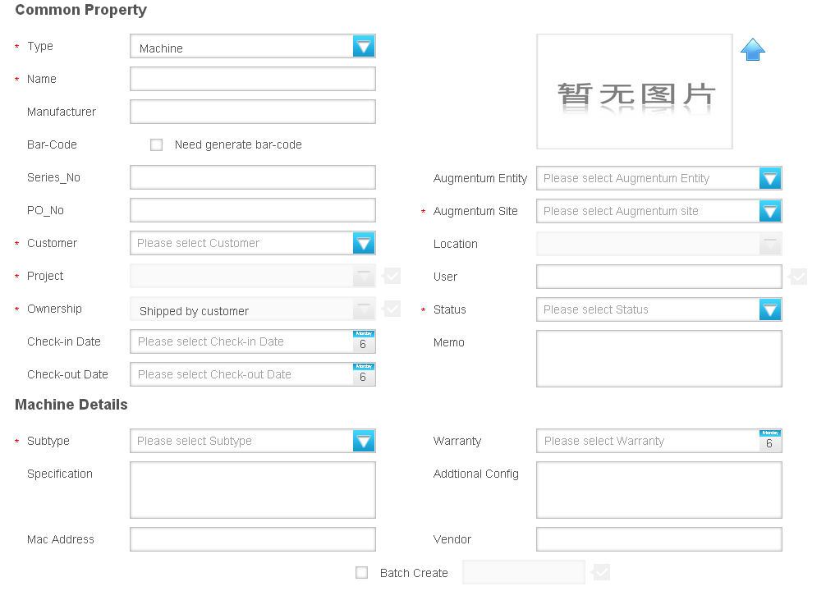
Several notes here:
- Customer and project are associated.(1*n), customer and project can be get from IAP by using web service
- Augmentum site and location are associated.(1*n)
- The user must belong to the project. (need confirm, now don't have restriction)
- When IT creating an asset, and while customer is Augmentum, Ownership field will automatically be “Augmentum”, and not editable.(need confirm, now the ownership is 'shipped by customer')
- While customer is Augmentum, user can be any employee of the company.
- While the Ownership is Augmentum or purchased by Augmentum but charge to customer, PO must be filled in. Otherwise, PO is not necessary.(need confirm, now don't have restriction)
- While PO is filled in, Augmentum Entity will be generated automatically.(need confirm, now don't have restriction)
- Check-in time can be filled or leave empty. If leaving empty, check-in time will be saved bu using asset record created time.
- If IT creates the assets, he/she can leave the customer/project/user to be empty. The asset can be assigned later.

Assets Info update
- Manager can update the user of the assets within his/her own project. The user must belong to this project.
- IT can update any info of the assets. Such as customer, project, Augmentum site, location, bar-code
- IT can batch generate the bar-code for selected assets. The batch generated code will be sent to IT to print them out.
- Fixed Assets (Y/N) is only visible by IT. The default value is N. Finance can single or batch update it to Y.
- When the user of an asset is rotated out from this project. User will be set to empty, status is idle, and a notice will be sent to this Manager. (Need confirm)
- Manager can defined properties for one asset type of one customer. The creation form is like below. Defined properties can be added to asset edit form.
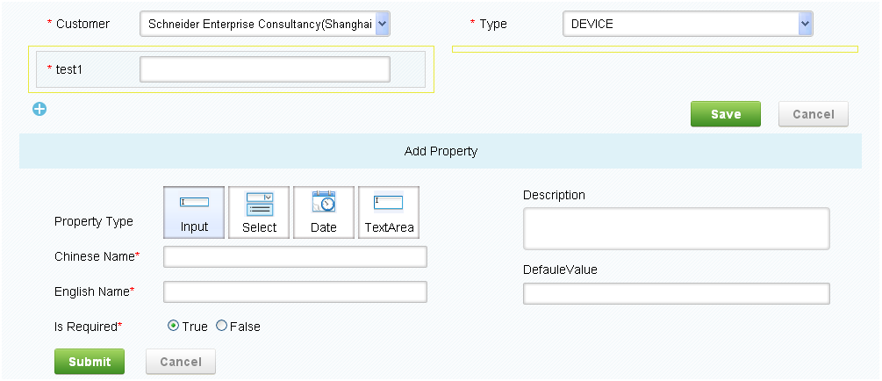

Confirm Process
Assets Assignment Confirm
When IT filled assets, he can leave the customer/project/user as empty and assign those info later. After IT assigns customer/project/user info to an asset, the manager of the project will receive a notice that requires his/her confirm. When manager logon the system, the confirm request record will be displayed on dashboard page. Manager should confirm the receipt of this asset.

Assets Return Confirm
Manager can return the assets to IT. He/she can select the asset from system, and click return button. Then a notice will be sent to IT to require the confirm of return. IT can see the confirm request record on the dashboard page after he/she logon. IT should confirm the return of this asset.

Newly Coming Assets Confirm
When PMS has completed a purchase order, PMS will send a message to AMS, AMS will get this message and analysis, displaying in main page - > newly Coming Assets. IT can view this part and click the asset name to complete asset information.

Process of project assets
- Employees take over assets by themselves
If the customer is a shared customer, or if the system admin define this customer as a shared customer, then all employees under this customer can view all customer assets in project assets list, and also can take over assets, no need manager to confirm.
- Manager or special role user can assign assets to one employee
Manager can assign a special role to employees who under his/hers project. If the employee has this role, he/she can help manager do same work as manager. Manager or special role user can assign assets to one employee

Authentication/Authorization
- There is a login page, and users can only login with correct username and password (Login function will use CAS)
- Leader's and Manager’s role can be retrieved from IAP
- IT's role is set by system admin of this system
- User should logout after finish using the system.
- 30 minutes time out if the page is idle

Dash Board
After every user logs in, there is a personal dash board page be displayed as the main page.
Employee/ Leader
- List how many assets he/she owns, classified by assets type.
- Having notice if his/hers assets were assigned or assigned out(need confirm)

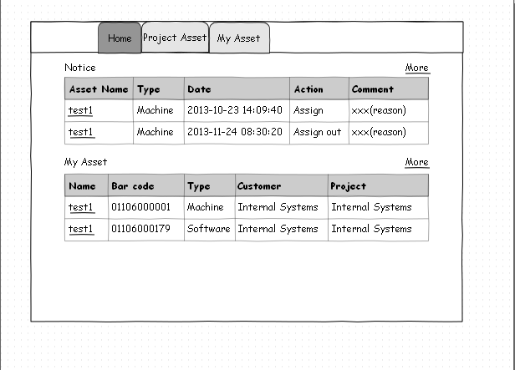
Manager
- List how many assets he/she owns, classified by assets type.
- List how many assets belong to his/her project, classified by assets type.
- List the assets assignment info that he/she needs to confirm
- List idle assets info that can be returned back to IT
- Having notice about which employee has taken over which asset if his/hers customer is a shared customer.(need confirm)
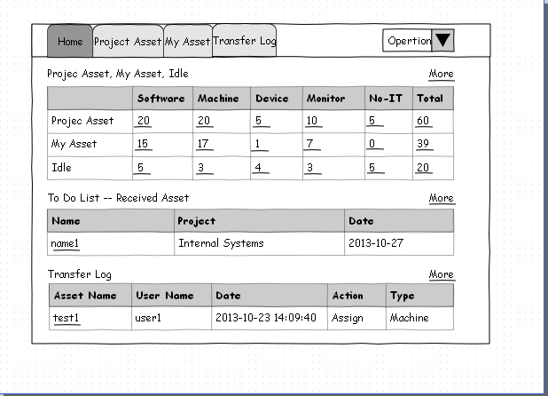
IT
- List how many assets he/she owns, classified by assets type.
- List all assets number the company has, classified by assets type.
- List all available/idle assets number the company has, classified by assets type.
- List newly coming assets which is from PMS
- List idle assets info
- List all the assets that warranty or license will be expired soon
- List the assets return info that IT needs to confirm
- List all assets number and Fixed Assets number
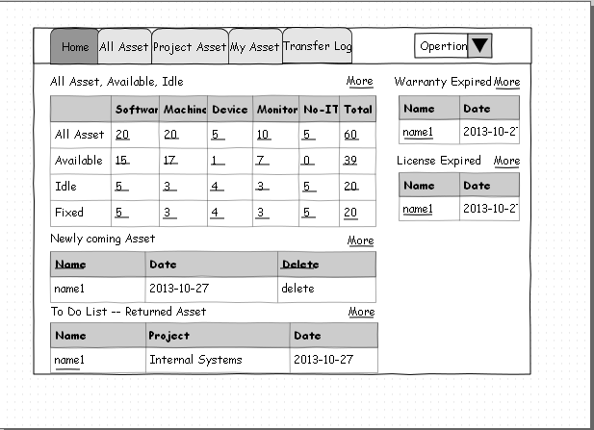
System admin
- List five records of users which is modifiled recently.(need confirm)
- List five records of customers which is modifiled recently.(need confirm)
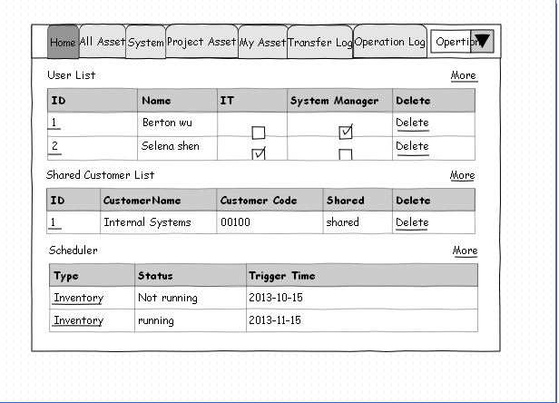
- List five records of scheduler information which is modifiled recently.(need confirm)

Search
Filter
Every user will have a search box on the page. It is a full text search that can search all kind of fields of assets. After the user input the keyword, and click search button, system will match the keyword of all the fields (e.g. memo, specification, manufacturer, etc). Note that the search will limit to the records that the user can view.
View
Every user can defined self views, in his/hers views, he/she can select a property, match condition, match values and so on. In his/hers list page, he/she can use view to filter search results.

Customized Column
Every user will choose he/she concerned column and select them in nine grids in list page. Next time he/she can only see customized column in list page. And he/she also can move the sequence of customized column, and the result will affect the sequence of data list columns.

Other functions
- System should support both Chinese/English. Also can be extended to more languages later
- CVS inventory records check.
- Bar-code will be batch generated by system. A mail will be sent to finance to print bar-code
- Can upload photo for one asset. Attachment file can be bmp, jpg, png, gif, eml, msg, mht. Attachment size should be less than 1M.
- There is a TODO list for IT to shows the request that need to be processed
- Mail function: A mail will be sent to asset user, manager, IT when an asset is updated.(Don't do)
- Each operation will be logged in database, and system admin can see the operation log.
- There is no physical delete in the system. All deletion is logical delete.
- There should be JS validation for field filling in.

Prerequisite Tools (minor version is flexible)
JDK 1.6
Log4J 1.2.16
JUnit 4.8.2
Tomcat 5.5.30
MySQL 5.5

Required Design Choices (minor version is flexible)
Logging
All logging of system information will be done with Log4J.

Unit Tests
All unit tests will be completed with JUnit test framework.

Internationalization (I18N)
String literals that can be localized later (visible labels, error messages, informational messages, etc.) must be in Java resource bundle.

Spring MVC
The presentation layer will be developed using Spring MVC.

Spring Framework 3.0.2
Use IOC/AOP to complete the business logic

Hibernate 3.5.3
Implement persistent layer with ORM.

New Feature (Need Confirm)
- Employee can report to repair
Employee can report a repair request when his/hers asset has problem
- Employee can add comment for assets
Employee can comment assets when he/she is the user of these assets and this comments can be sent to PMS system.
- Reports
Asset assignment report
Asset repair report
Return back report
Idle assets report
- Assets classified management
System admin can maintain assets classified management
- Extended Assets Attributions management
Manager can add extended assets attributions for one customer
- Manger can assign role “leader” to an employee
Manger can assign project role “leader” to an employee, when the employee has this role, he/she can assign assets to other employees.
- Assets depreciation management
IT can process this operation for assets.

